1. Order by clause.

Ans. select * from movies1 order by date1;

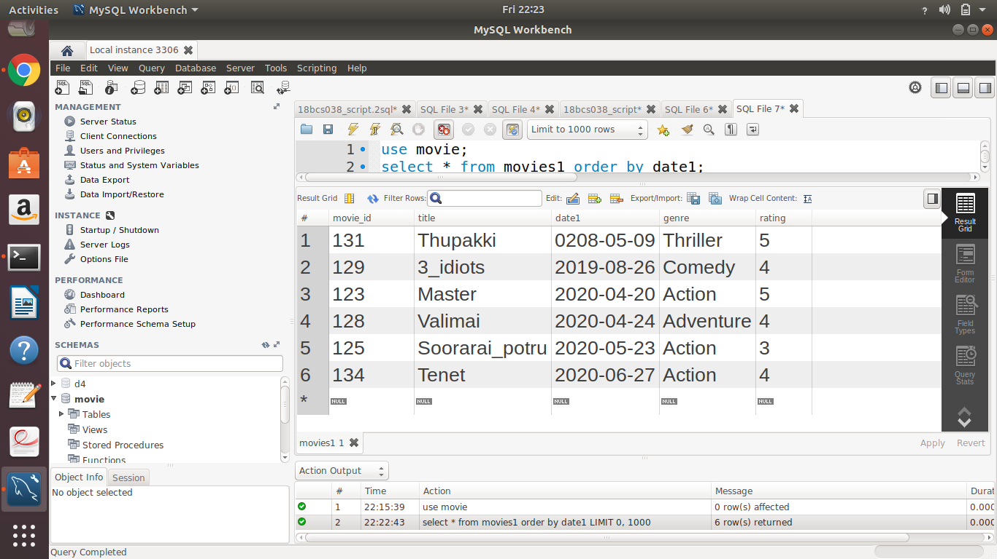

1. Group by and having.

Ans. select * from movies1 group by genre having rating >= 4;

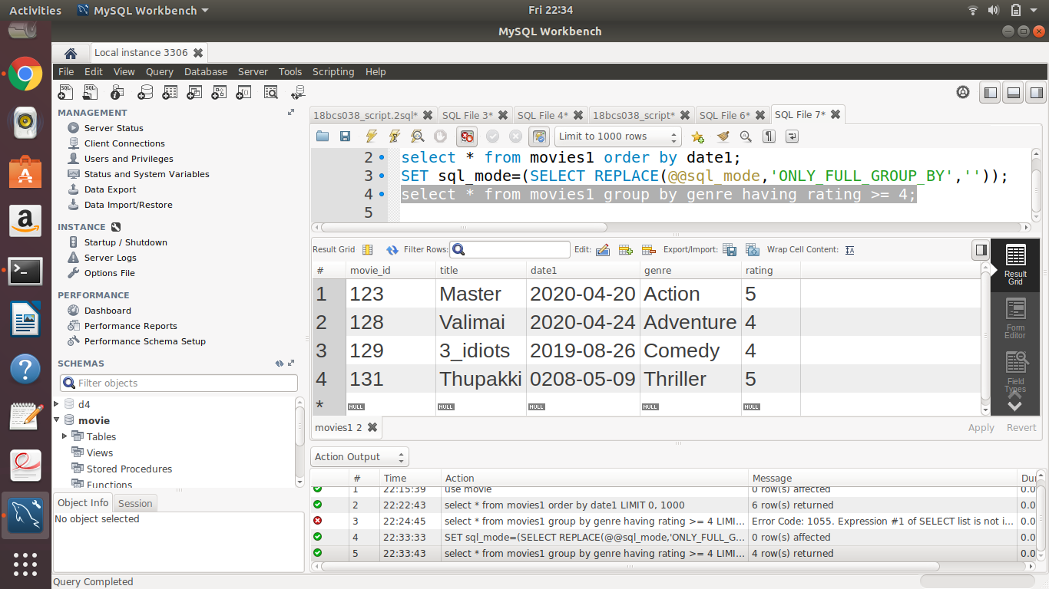

1. Aggregate functions.

Ans. select avg(rating) from movies1 where left(date1,4)="2020";

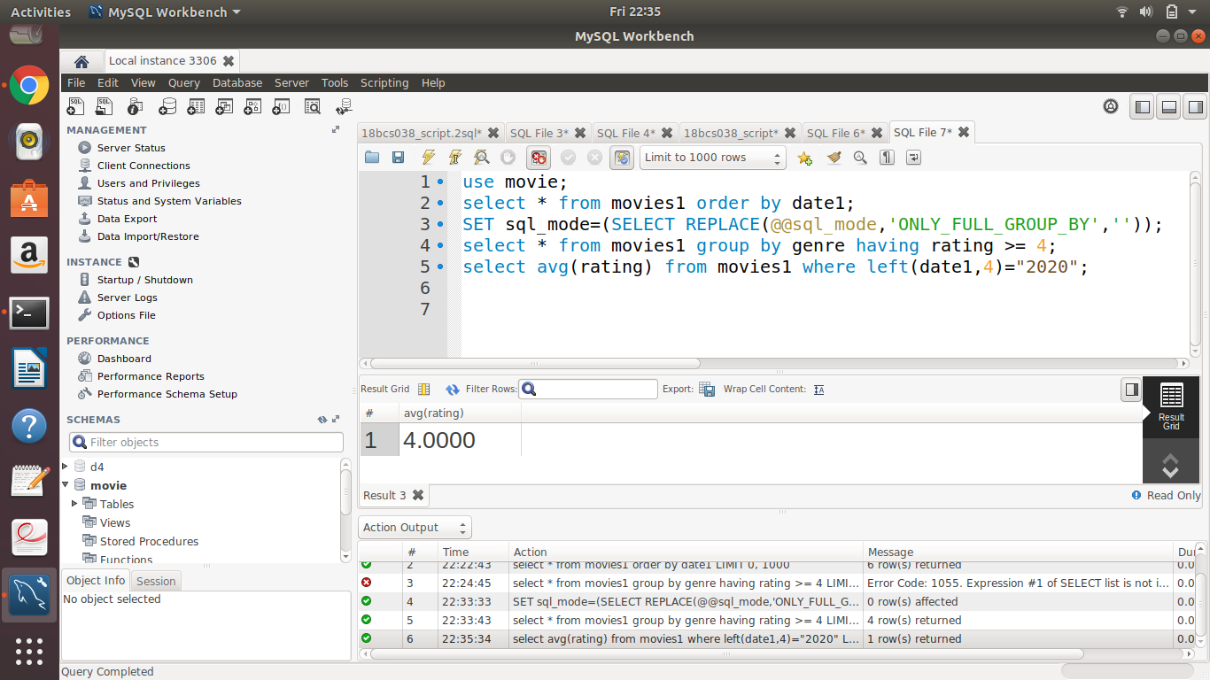

1. Logical operators especially with LIKE.

Ans. select * from movies1 where title like 'T%';

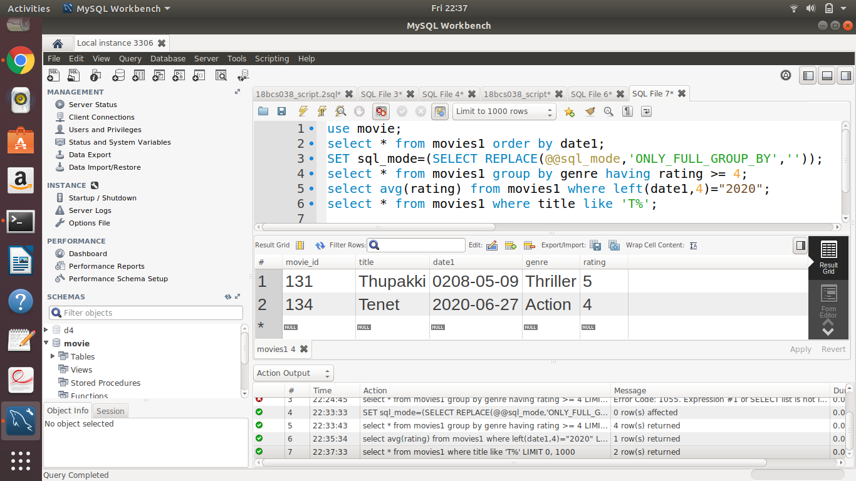

1. At least 4 nested queries specific to your Database, out of which at least 2 should have multiple subquery.

Ans.

A.

select m.title, s.song_name from songs s,movies1 m where m.movie_id in (select m.movie_id where m.movie_id=s.movie_id);

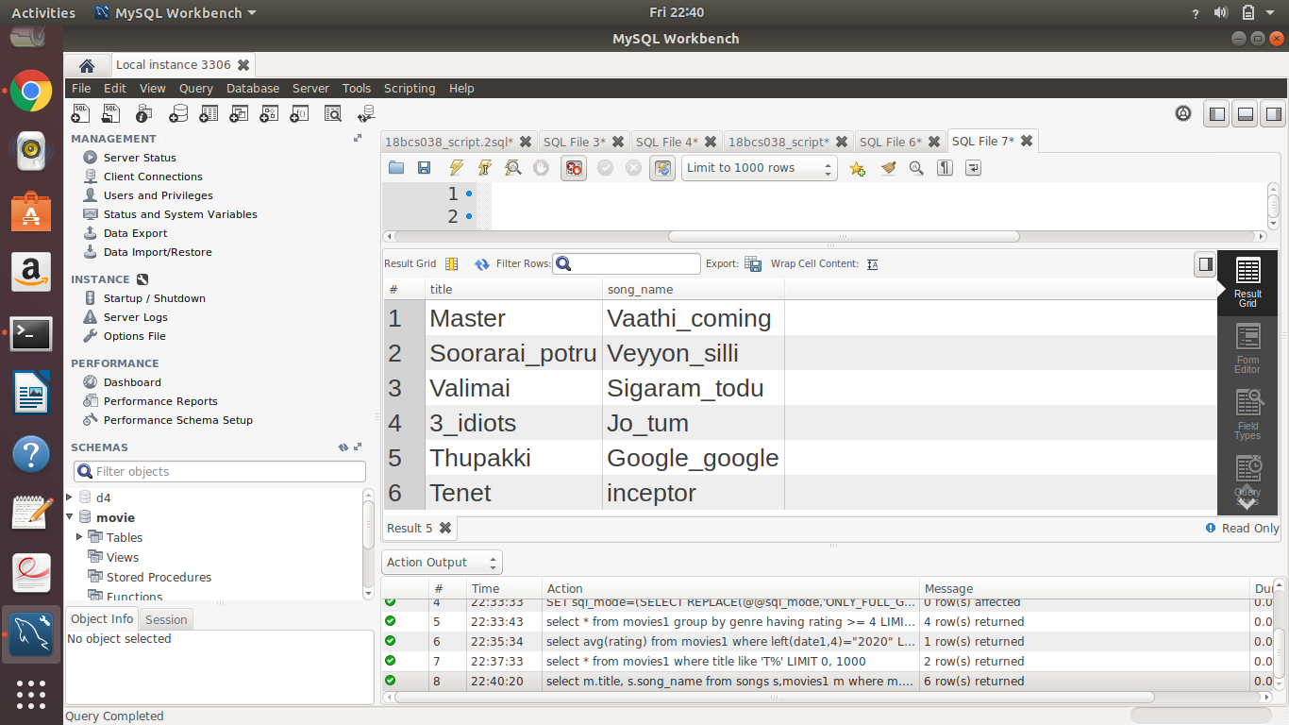

B.

select m.title , s.song_name from songs s, movies1 m where m.movie_id=(select m.movie_id where m.movie_id=s.movie_id and m.title="Master");

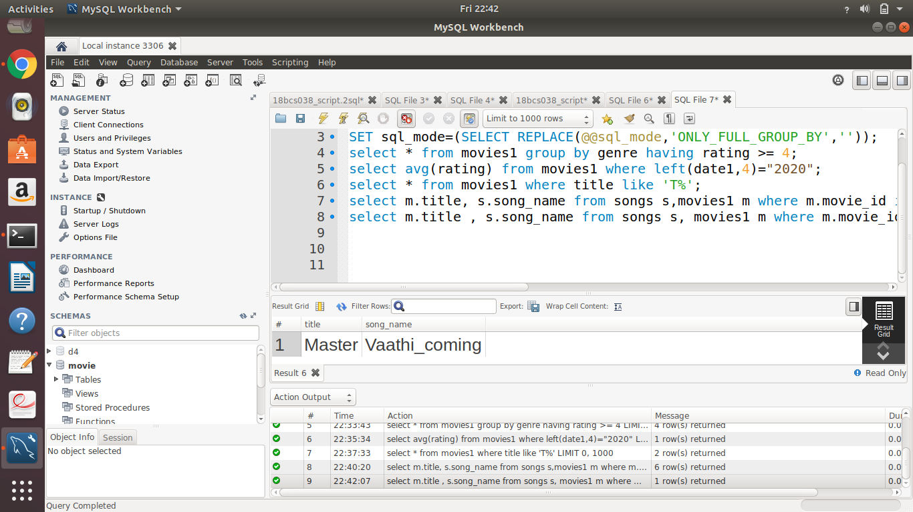

C.

**Query:**

select movie_id,title from movies1 where rating>(select avg(rating) from movies1 where genre=(select genre from movies1 where movies1.movie_id=134))and genre in(select genre from movies1 where movies1.movie_id=134);

**Explanation:**

/*The inner query returns the average of the ratings of those movies with genre same as the genre of movies with movie_id=134. The outer query displays the movie details with rating > the value returned by the inner query and with genre same as that with movie_id=134.*/

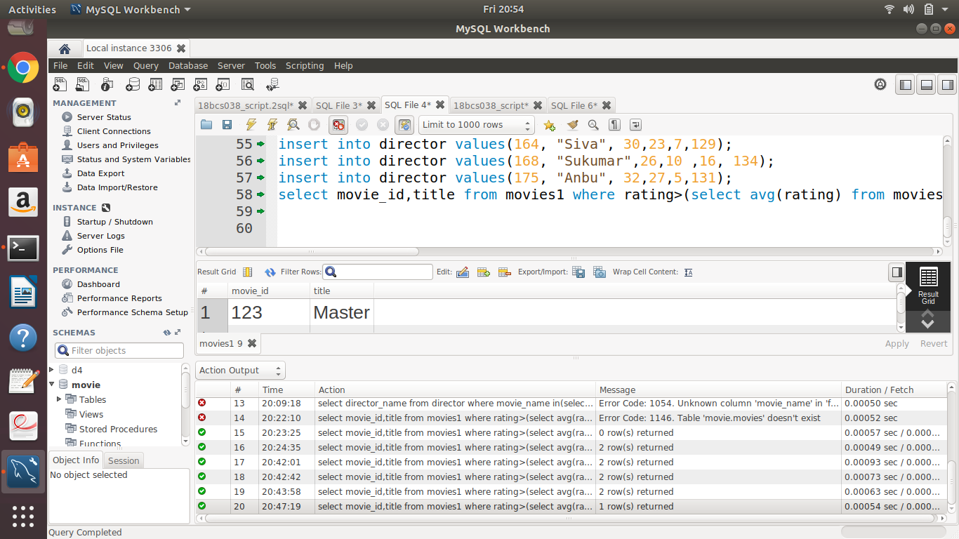

D.

**Query:**

select songs.song_name,songs.singer from songs where songs.movie_id in(select movie_id from director where no_of_flops >(select min(no_of_flops) from director));

**Explanation:**

/*Displays the song name and singer from the songs of movies directed by directors with no_of_flops greater than the minimum number of flops of any director from the director table*/

